**Creating firewall rule**

1. Open cloud shell editor from gcp console.

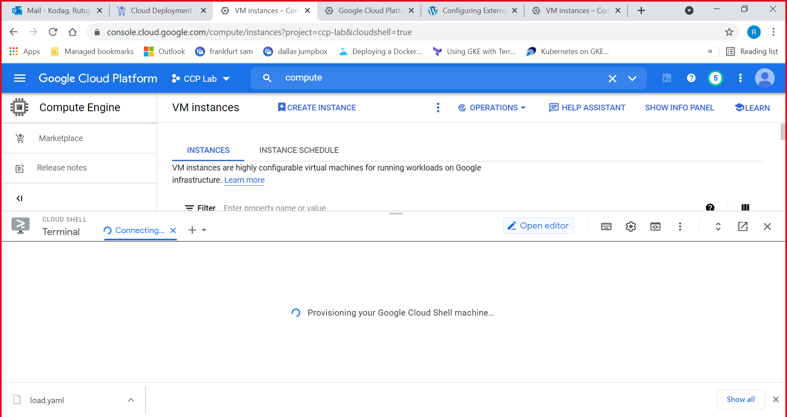

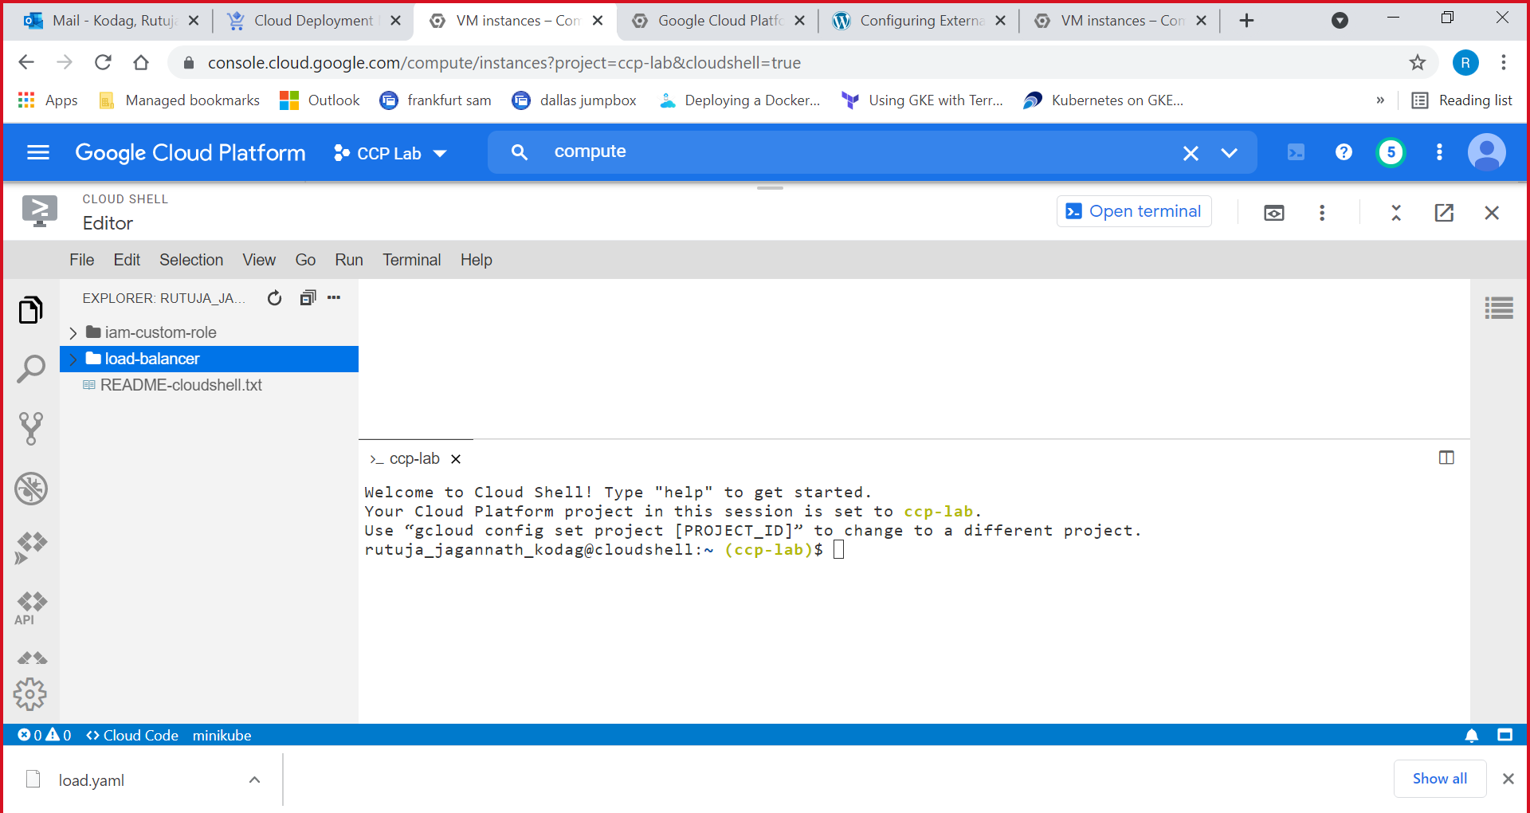

1. Write the YAML configuration file in editor. Open terminal and run the command for deployment.

$ gcloud deployment-manager deployments create firewall-deployment --config firewall.yaml

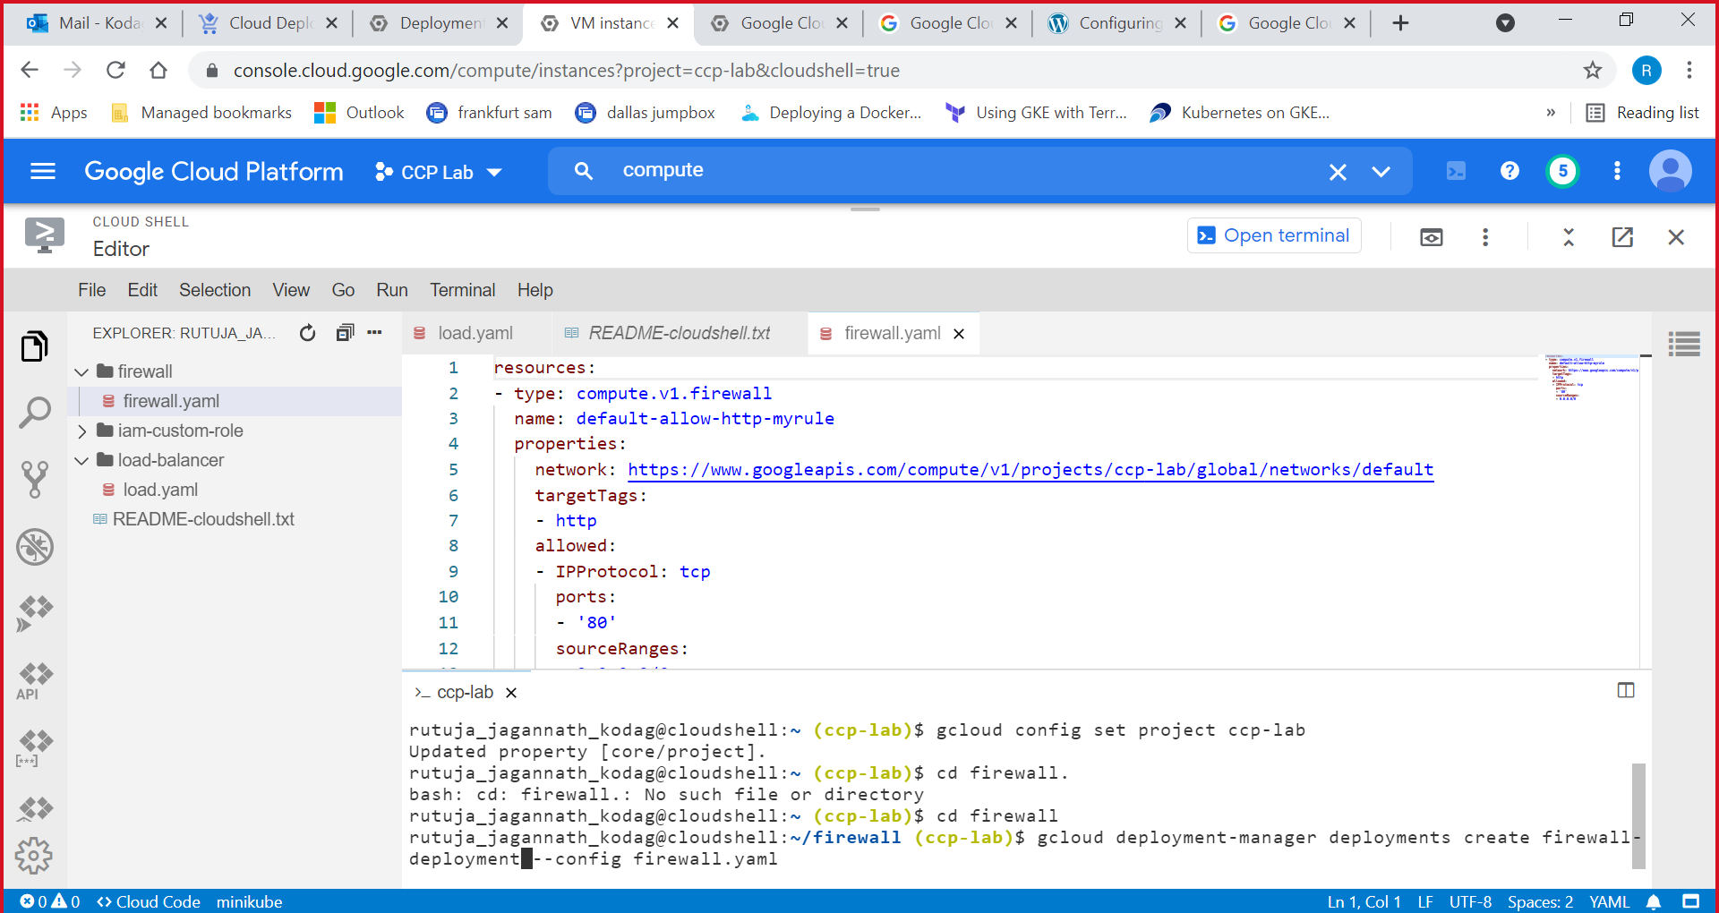

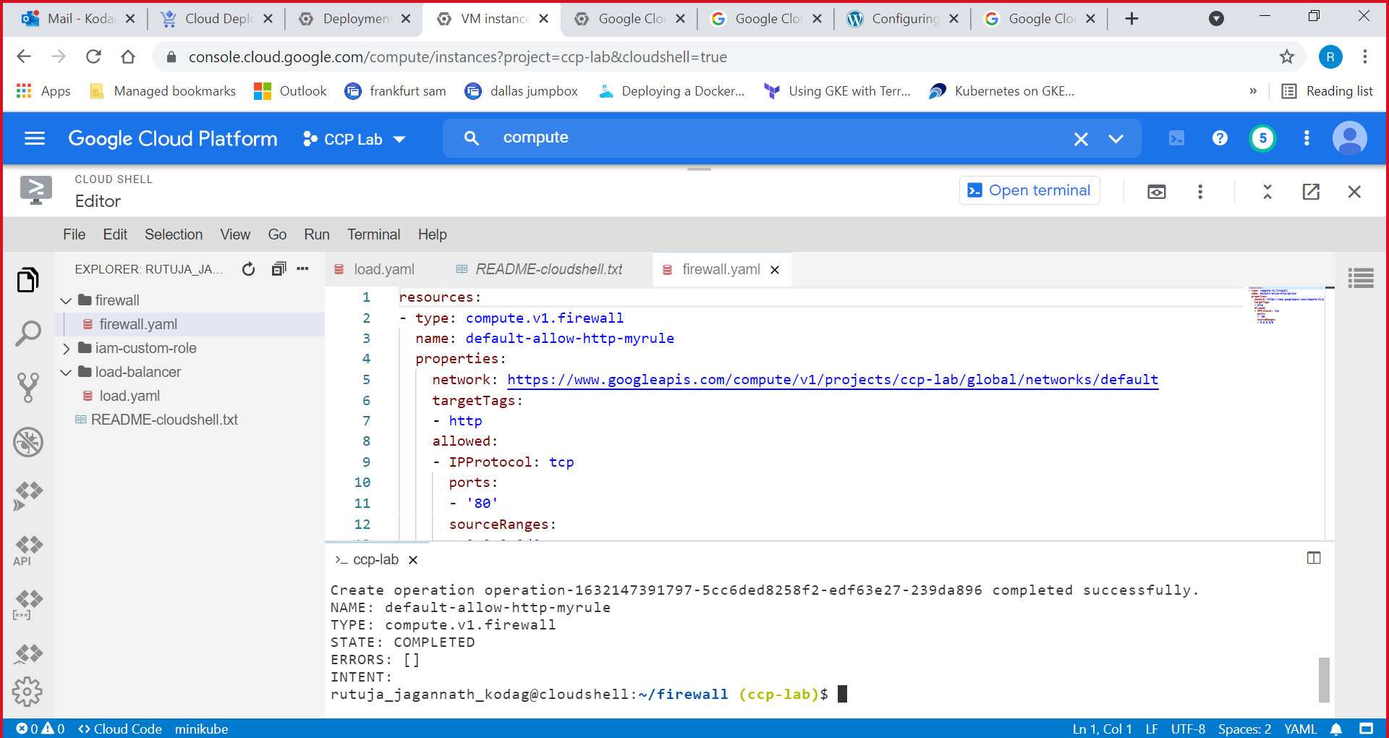

1. See the output on GCP Console.

